

**CIRCUIT AND SYSTEM-2 LAB**

**Lab:03**

**Inductive Reactance**

**SUBMITTED BY : Tayyaba**

**SUBMITTED TO: SIR FAIZ ULLAH**

**REGISTRATION N0 : 19PWCSE1854**

**SECTION : C**

**DATE : 14.12.2020**

**Objective:**

* Inductive reactance will be examined in this exercise.
* In particular, its relationship to inductance and frequency will be investigated, including a plot of inductive reactance versus frequency.

**Theory:**

The current – voltage characteristic of an inductor is unlike that of typical resistors. While resistors show a constant resistance value over a wide range of frequencies, the equivalent ohmic value for an inductor, known as **inductive** **reactance.**It is directly proportional to frequency.

The inductive reactance may be computed via the formula:

**XL= 2πfL**

The magnitude of inductive reactance may be determined experimentally by feeding an inductor a known current, measuring the resulting voltage, and dividing the two, following Ohm’s Law. This process may be repeated across a range of frequencies in order to obtain a plot of inductive reactance versus frequency. An AC current source may be approximated by placing a large resistance in series with an AC voltage, the resistance being considerably larger than the maximum reactance expected.

**Equipment:**

1. AC Function Generator

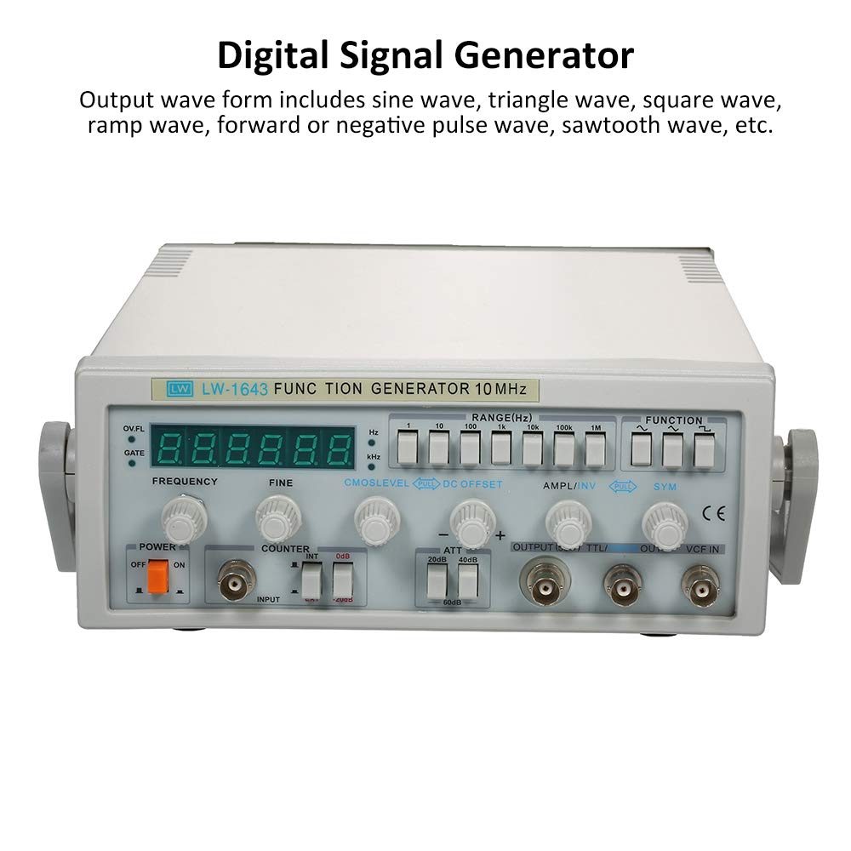

1. Oscilloscope

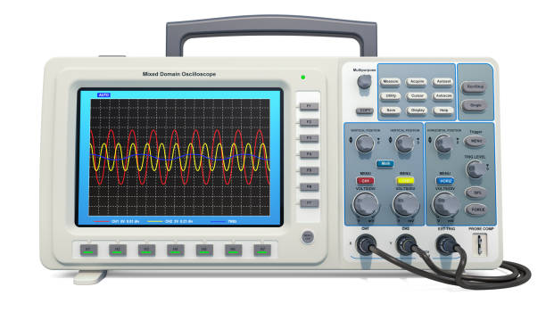

**Components:**

1. 1 mH actual:__________________

2. 10 mH actual:__________________

3. 10 kΩ actual:__________________

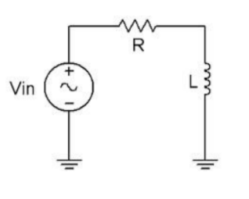

**Figure 1**

**Procedure:**

**1. Current Source:**

Using Figure 1 with Vin=10 Vp-p and R=10 kΩ, and assuming that the reactance of the inductor is much smaller than 10k and can be ignored, determine the circulating current using measured component values and record in Table 1.

**2. Measuring Reactance:**

Build the circuit of Figure 1 using R=10 kΩ, and L=10 mH. Place one probe across the generator and another across the inductor. Set the generator to a 1000 Hz sine wave and 10Vp-p. Make sure that the Bandwidth Limit of the oscilloscope is engaged for both channels. This will reduce the signal noise and make for more accurate readings.

3. Calculate the theoretical value of XL using the measured inductor value and record in Table2.

4. Record the peak-to-peak inductor voltage and record in Table 2.

5. Using the source current from Table 1 and the measured inductor voltage, determine the experimental reactance and record it in Table 2. Also compute and record the deviation.

6. Repeat steps three through five for the remaining frequencies of Table 2.

7. Replace the 10 mH inductor with the 1mH unit and repeat steps two through six, recording results in Table 3.

8. Using the data of Tables 2 and 3, create plots of inductive reactance versus frequency.

|  |  |
| --- | --- |
| I source (p-p) | o.oo1A |

**Table 1**

**CIRCUIT DIAGRAM:**

**For 1mH:**

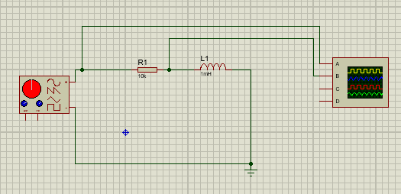

**For 10mH:**

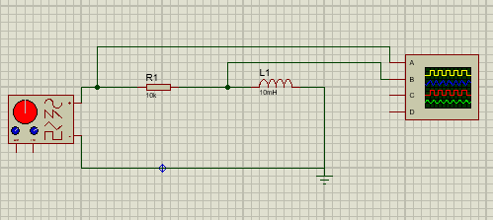

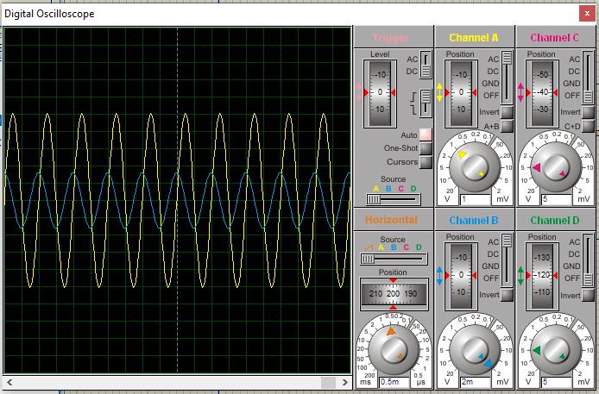

|  |  |  |  |  |
| --- | --- | --- | --- | --- |
| **Frequency** | **XL Theory** | **VL(p-p)  Exp** | **XL Exp** | **%Dev** |
| **1k** | **6.3 ohm** | **6.3 mV** | **6.28 ohm** | **0.31 %** |
| **2k** | **11.4 ohm** | **11.4 mV** | **12.46 ohm** | **-1.29 %** |
| **3k** | **14.6 ohm** | **14.6 mV** | **18.54 ohm** | **-7.04 %** |
| **4k** | **22.6 ohm** | **22.6 mV** | **25.62 ohm** | **1.875 %** |
| **5k** | **31 ohm** | **31 mV** | **31.74 ohm** | **1.87 %** |
| **6k** | **38.2 ohm** | **38.2 mV** | **37.78 ohm** | **3.8 %** |
| **8k** | **51 ohm** | **51 mV** | **52.84 ohm** | **3.38 %** |
| **10k** | **64.9 ohm** | **64.9 mV** | **61.8 ohm** | **3.08 %** |

**Table 2**

**GRAPH:**

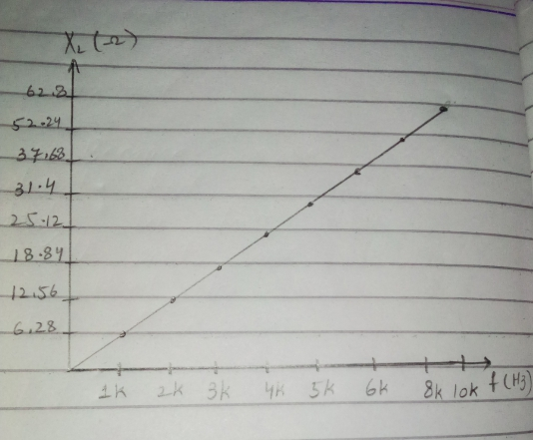

|  |  |  |  |  |
| --- | --- | --- | --- | --- |
| **Frequency** | **XL Theory** | **VL(p-p)  Exp** | **XL Exp** | **%Dev** |
| **11k** | **628 ohm** | **0.64 mV** | **620 ohm** | **-1.91 %** |
| **22k** | **1286 ohm** | **1.38 mV** | **1220 ohm** | **-1.91 %** |
| **31k** | **1874 ohm** | **1.22 mV** | **1930 ohm** | **-1.91 %** |
| **41k** | **2562 ohm** | **2.56 mV** | **2540 ohm** | **-1.91 %** |
| **51k** | **3150 ohm** | **3 mV** | **3070 ohm** | **4.45 %** |
| **64k** | **3748 ohm** | **3.66 mV** | **3660 ohm** | **4.45 %** |
| **879k** | **5034 ohm** | **4.66 mV** | **4550 ohm** | **9.23 %** |
| **102k** | **6282 ohm** | **6.03 mV** | **6012 ohm** | **4.45 %** |

**Table 3**

**GRAPH:**

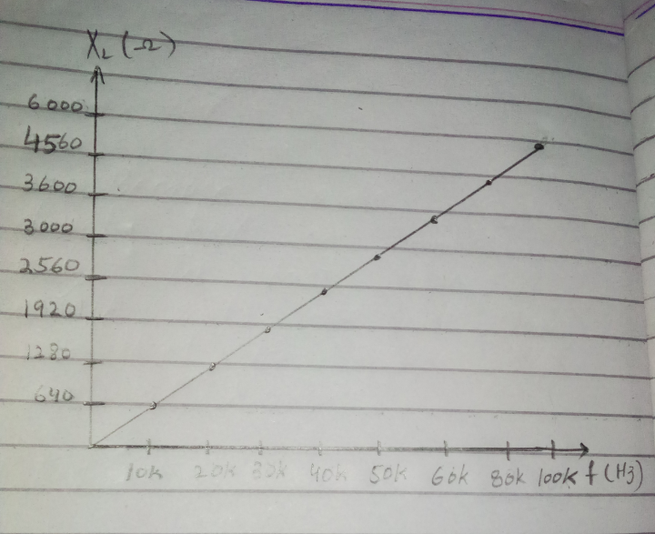

**Questions:**

1. What is the relationship between inductive reactance and frequency?

ANSWER:

* Inductive reactance is directly related with frequency.

**XL α ƒ**

* The **inductive reactance of** an inductor increases as the **frequency** across it increases and vice versa.

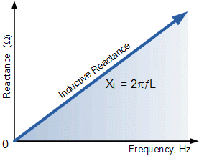

1. What is the relationship between inductive reactance and inductance?

ANSWER:

Inductive reactance and inductance is directly proportion to each other . From formula

**X = 2 $π$ fL**

**XL L**

1. If the 10mH trial had been repeated with frequencies 10 times higher than those in Table 2, what effect would that have on the experiment?

ANSWER:

**XL L**

So by increasing frequency 10 times in table 2 the value of reactance increases 10 times.

1. Do the coil resistances have any effect on the plots?

ANSWER:

Yes coil resistances effect the plots , their resistance vary by increasing and decreasing frequency.